

SETP4583
SURFACTANT AND DETERGENT TECHNOLOGY
EB01

INDIVIDUAL REFLECTIVE JOURNAL ASSIGNMENT

LECTURER:
DR. AZAD ANUGERAH BIN ALI RASOL

NAME:
WOO CHENG SHUAN
A23CS0283

1.0 INTRODUCTION
In the beginning, I thought that this course would enhance my knowledge on chemical structures since I had previously studied general chemistry in high school. I was also particularly keen on observing how this basic knowledge can be used in a more practical and industrial way and in particular when formulating detergents. Another area I was not eager to miss was the laboratory sessions where I would get to examine and investigate the various varieties of detergents in the market to be in a position to relate the theory with actual products. This course has been selected since I was interested in the detergent business and thought that I would be able to gain some real interest in this area. Comprehensively, I have aimed to acquire theoretical information and practical experience that would assist me in learning more about the way in which the daily consumer products are developed and tested scientifically.

2.0 REFLECTION ON KEY LEARNINGS
Among the important lessons that I had during this course was that of the importance of ratios of surfactant ingredient in the daily detergent products. My preconceived thoughts about detergents before attending this course were that they are basically differentiated by brand or smell. Nonetheless, during lectures and laboratory work, I came to understand that the performance, safety and environmental effect of a detergent is strongly influenced by the kind and the amount of surfactants incorporated in the formulation of the product. Any slight alteration of the ratio might influence cleaning effectiveness, foaming performance, skin affinity, and biodegradability.

One crucial idea that I got was that most of the dirt and oil eliminating properties are carried out by surfactants at the molecular level, and the various types of surfactants, anionic, non-ionic, cationic, and amphoteric, have different chemical structures and characteristics. The explanation and demonstrations of the lecturer made me clearly understand why one surfactant is seldom adequate in commercial formulations of detergents. Rather, they are chosen in a combination in order to balance power, mildness, cost, and environmental sustainability. It was a significant milestone in my knowledge of detergent science.

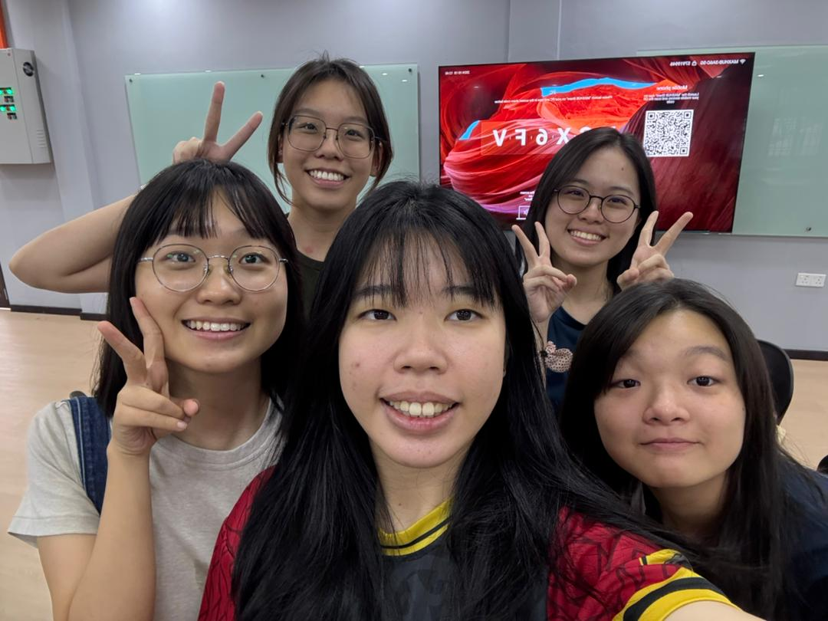
Figure 1: Group photo with my teammates
Among the key ‘aha’ experiences was the time the lecturer demonstrated various samples of the surfactants and told us about their respective properties, including foaming properties, strength of the detergency, and potential skin irritation. I learnt that cleaning agents are not necessarily the best to use in products that are used on a daily basis especially those that are meant to come into contact with human beings frequently. This realization made me realize the importance of biodegradable and skin friendly formulations in the development of modern detergents.

These ideas were also strengthened in laboratory sessions where we got a chance to compare and interpret the various detergents in the market. The way the changes in formulation influenced the product performance allowed closing the gap between theory and practice. This practical experience helped me understand better the scientific decision-making process in the creation of safe and effective household products.

All in all, this course has greatly contributed to my knowledge on the application of the principles of chemistry in the development of the detergents. It opened my eyes on the regular consumer products and the need to formulate them in a responsible manner that could take care of both user safety and the environment.

3.0 APPLICATION AND REAL-WORLD RELEVANCE
Since I heard about the formulation of detergents and the property of surfactants, I am now becoming more aware and knowledgeable in my choices to acquire the following items in the household like shampoo and laundry detergent. My major attention was centered on some factors such as brand reputation, fragrance or price in the past. Nonetheless, this course has altered my perception of these products since now I much more attentively consider the list of ingredients and the formulation information. With the knowledge of the role of various surfactants, I would be able to evaluate the potential of a certain product to be effective and safe to be used on a regular basis.

An example of this is in purchasing a shampoo now I would make sure that milder and biodegradable surfactants are available which will not cause irritation of the skin or scalp. I also understand more that products containing excessive strength of surfactants can offer high cleaning properties but can be depilitating to the natural oils causing them to be dry or sensitive. This information will assist me in making more balanced decisions and be based on the performance and friendliness of skin. In a similar manner, in choosing laundry detergents, I will look at whether the formulation has surfactants with enough cleaning ability, and at the same time, it should be environmentally friendly.

Moreover, the course was able to make me realize that there is no single ingredient that defines the quality of products. Rather, the performance of a product is determined by its ingredients mix and proportionality. This knowledge will enable me to be more critical with ingredient labels and not always assume that all chemical-sounding names are dangerous. I am now more confident to make a comparison of the products and make informed judgments on the basis of their purpose of formulation.

In general, the lessons I acquired during this course have an application to my everyday life. It has made me a more active consumer rather than a passive one that thinks safety, effectiveness, and environmental impact. Through this practical example, one can see that scientific knowledge may have a direct impact on daily decision-making and encourage more sustainable consumption patterns and healthy ones.

4.0 CHALLENGES AND GROWTH
A primary issue that encountered in the course was the need to comprehend the chemical conceptions of surfactant structures and the interaction on a molecular level. I did possess some basic knowledge about chemistry in high school, but I needed to gain better analytical understanding to apply these concepts in actual detergent formulations. At the onset, the words used were hydrophilic-lipophilic balance, biodegradability, and the classification of surfactants which ere baffling and in visualization.

In order to solve this dilemma, I tried to go through lecture material regularly and correlate it to examples that were discussed in the classroom. The laboratory sessions were important in enabling me to gain an insight on these abstract concepts because the theory became more significant when I saw how various formulations worked in reality. Another lesson I acquired is to ask questions in lectures and on any discussions that I did not understand which clarified my confusions and this boosted my confidence in the topic.

The other obstacle was to change my mindset about memorizing the information about chemicals to the real life application. This course has made me think critically as to why specific ingredients were selected and how formulation decisions impact on product performance, safety and environmental impact. As time progressed, I got more used to analyzing problems instead of finding simple solutions.

These challenges helped me to become more skilled in solving problems, and more analytical in my learning process. I also got the confidence to deal with scientific material which seemed daunting at the beginning. On the whole, these experiences helped me to not only develop as an academic, but also as a person, by showing me the value of persistence, curiosity and being an active participant in the learning process.

5.0 PERSONAL AND PROFESSIONAL DEVELOPMENT
This course has had a considerable impact on personal and professional growth since it has broadened my vision of the detergent and personal care industry. By understanding the science of surfactant chemistry, formulation and other sustainability issues, I have gained greater interest in the scientific way everyday consumer products are formulated. What began as a simple inquisition has become a more serious thought of the field as a prospective area of future research or career opportunity.
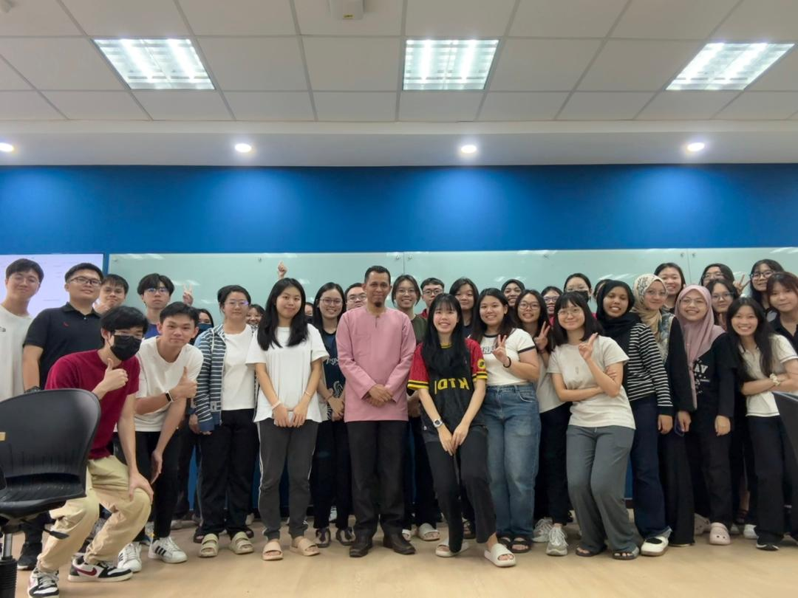
Figure 2: Group photo with Dr. Azad and classmates
At a personal level, the course has enhanced my critical thinking and analysis, since I have learned to judge products in terms of their formulation, and not in terms of superficiality like branding or marketing. I have also become more environmentally aware, in particular, the relevance of biodegradable and skin-friendly ingredients. This consciousness has not only impacted on my buying behavior, but also my general attitude toward responsible consumption.

On the professional side, this course has helped me gain a solid background of applied chemical information that may be applied in an industry dealing with formulation, quality control or product development. I would also like to venture further into more high-technology issues of sustainable detergent technologies and green chemistry in the future because this is what is needed in the industry as well as environmental responsibility.

